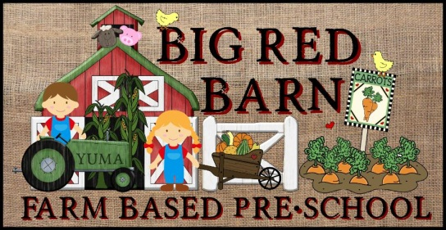

Big Red Barn Preschool
2175 S. Arizona Ave Yuma, AZ 85364
Phone (928) 783-3815 Fax (928) 783-3835
brbpreschoolyuma@gmail.com
www.brbpreschoolyuma.com

Enrollment/Information Form

Date______________________

Childs Name__________________________ Child’s age____________________

Child’s Birthday________________________ Nickname_____________________

Address_______________________________________________________________

Contact Info:

Mom’s name_______________________________________________

Dad’s name________________________________________________

Mothers Employer ______________________________________________
Email Address___________________________________
Work Phone____________________________________
Cell Phone_____________________________________

Fathers Employer ______________________________________________
Email Address___________________________________
Work Phone____________________________________
Cell Phone_____________________________________

Are there any marriage, custody, step parent etc. arrangements or issues we should be aware of? __________________________________________________________________________________________________________________________________________________________________________________________________________________________________________

Emergency Contact Person_________________________________
Relationship ____________________________________________
Contact’s phone__________________________________________
Emergency Contact Person_________________________________
Relationship _____________________________________________
Contact’s phone__________________________________________

Service Info:
Enrollment date______________________________________________

Which program are you interested in:
M-F Full Day _____
M-F Half Day _____
MWF Full Day _____
MWF Half Day _____
TTH Full Day _____
TTh Half Day _____
After School _____

Your Child’s Health

CHILD'S HEALTH RECORD: (A copy of your child's immunizations and current physical will be needed)

General state of health: ______________________________________________________________________
______________________________________________________________________
Doctor’s name______________________________________________________
Doctor’s phone number_______________________________________________

Are your child's immunizations up to date? _________ (Please attach a copy of immunizations.)
Does your child have any known allergies? ______________________________________________________________________
______________________________________________________________________
Are you concerned that your child may be prone to any type of allergies?___________
Describe: ______________________________________________________________________________

Does your child have any medical conditions which we should be made aware of? ____________________________________________________________________________________________________________________________________________

Does your child have any speech, hearing or visual problems? ______________________________________________________________________
Would there be any restrictions to play or activities? ______________________________________________________________________
______________________________________________________________________

About Your Child

Has your child ever been in child care before?_________ What type (center, family daycare, grandma etc.)___________________________________________________

Was it a positive experience? ____________________________________________________________

Does your child like to play outside? ______________________________________________________________________
Does your child have any experience with animals? ____________________________________________________________________________________________________________________________________________________________

Are there any recent traumatic situations the child has been exposed to such as a death in the family, divorce, new sibling etc.? ____________________________________________________________________________________________________________________________________________________________

What is your normal method of discipline? ______________________________________________________________________

What is your child's temperament? Are they easy going, hard to please, demanding, aggressive, etc. ______________________________________________________________________
_________________________________________________________________________

Are there any food restrictions? ____________________________________________________________________________________________________________________________________________________________
What is your child's favorite food? __________________________________________
What food does your child dislike? __________________________________________

Is your child potty trained?__________________

Can your child be relied upon to indicate bathroom wishes? _________________________
Does your child nap or do a quiet time? __________________________________

Does your child have any additional sleeping concerns or issues? _________________ ______________________________________________________________________
Are there any siblings? Please name them and specify ages and gender.
Name _____________________ age __________________ gender _______________
Name _____________________ age __________________ gender _______________
Name _____________________ age __________________ gender _______________
Has your child had experience playing with other children? ______________________
______________________________________________________________________
What language(s) are spoken at home? _____________________________________________________________________
Does your child have any security objects such as a blanket or a toy? _____________________________________________________________________
______________________________________________________________________

Are there any other comments or information you would like to let me know about? ______________________________________________________________________________
____________________________________________________________________________________________________________________________________________________________

Thank you for proving us with the necessary information to help ensure the best possible care and education for your child. Please feel free to contact us directly with any additional question, concerns or issues you would like to discuss.

Signature _______________________________ Date ____________________

