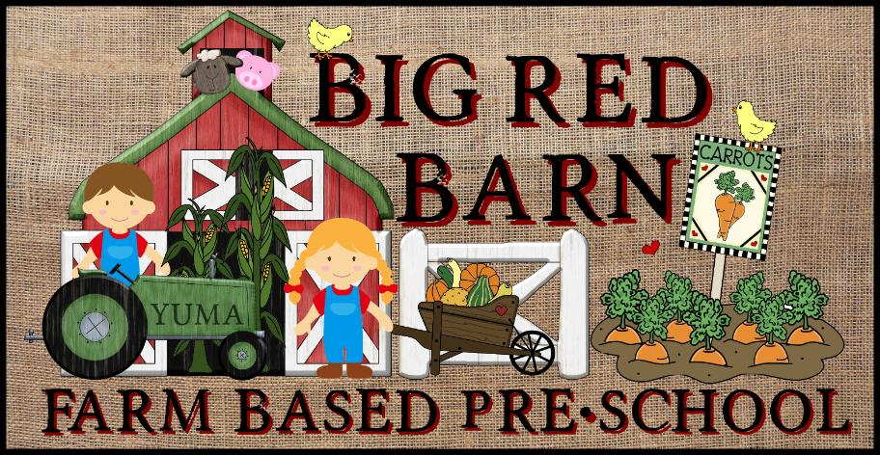
Big Red Barn Preschool
2175 S. Arizona Ave
Yuma, AZ 85364
Phone: (928) 783-3815
Email: brbpreschoolyuma@gmail.com
Website: www.brbpreschoolyuma.com

Sponsorship Packets

Who WE are…
We are Big Red Barn Farm based Preschool.
Our unique approach allows each child to grow and develop in a natural environment while interacting with the world around them.
Big Red Barn has a comprehensive curriculum that fosters an appreciation for agriculture’s contribution to society. The curriculum focuses on agriculture, animals, and an appreciation for our environment. We provide a positive atmosphere for physical, social, emotional and intellectual growth. This whole child approach allows each child the opportunity for direct interaction with plants and animals while learning the important aspects of care and conservation of our world.
Big Red Barn has a beautiful organic garden soon to be filled with fruits and vegetables sure to fill the curiosity and stomachs of your children. We believe that children should experience good old outside playtime complete with games, potato sack races, water play, tricycles, and hands on activities to develop confidence in physical capabilities. We embrace the concepts of discovery-based learning through play, sensory exploration, creative expression, and most importantly making friends and developing social skills.
At Big Red Barn the learning doesn’t just happen outdoors. Step in to the classroom and let the experience continue. Each classroom is furnished with toys and materials to develop social and cognitive skill development, gross and fine motor skill development, lots of natural science exploration and includes a variety of fun accessories to foster hours of creative play. The Zoo-phonics program and hands on math and science activities ensure your child has fun while learning all of the skills essential for kindergarten success. Arts, crafts, music, song, and rhyme are part of every lesson every day to encourage participation and retention of basic skills. . Children will be building their knowledge through their first-hand experiences with nature, classroom materials, and their relationships with peers and adults. We hope to inspire each child to build a lifelong relationship with the natural world around them.
Each of our classrooms is staffed with highly educated teachers and assistant teachers to ensure each child receives the entire one on one attention and care they deserve. Rich curriculum, lesson plans, filed trips, guest speakers and parent and community involvement is key to us at the Big Red Barn. We strive to provide and experience for your child like no other.

Why we need YOU…
We are trying to provide a special experience for every child and family that enters our school. We want to provide the opportunity for every student to plant a garden, play with ladybugs, feed a goat and get their hands dirty while they learn and have a blast doing it. These types of experiences cost money and take ongoing time and effort to provide. We want to be a community based program that gives as much as it gets. We want to help encourage and empower young minds to be more agriculturally educated and involved in our community. Your support can be shown in many ways:
- Support of our program in the community
- Financially
- Goods and services
- Discounts or donations
- Time and efforts
- Expertise and knowledge

What we have to offer YOU…
- A display of your business cards and banner at our Preschool location.
- Your business names on our newsletters, advertisements and print media as Big Red Barn supporters.
- A banner display during any of our community events such as parades, programs and etc.
- The opportunity to be a guest speaker at our school.
- Your business name on a plaque as a Big Red Barn supporter to be displayed.
- The opportunity to be involved in the growth and development of children while promoting agriculture and education in our community.

Thank You…
We appreciate your time, consideration and support.
Company Name:
Contact Person:
Phone Number:

____ Yes, We would like to help Big Red Barn by
____ Being a guest speaker or providing expertise
____ Discounting or donating supplies or services
____ Financial contribution
____ Donation of time
____________________________________________________________________________________________________________________________________________________________________________________________________________________________________________________________________________________________________________________________________________________________________________________________________________________________________________________________________________________

____ Not at this time

____ I would like to further discuss the options. Please contact Sandra Escalante at 446-1099 or Suzette Reyes at 446-6297.

We cannot always build the future for our youth, but we can build our youth for the future. ~Franklin D. Roosevelt

